**Bartlett Cocke Const.** **Killeen East Ward/West Ward Consolidation**

**Monthly Progress Report – June 2020**

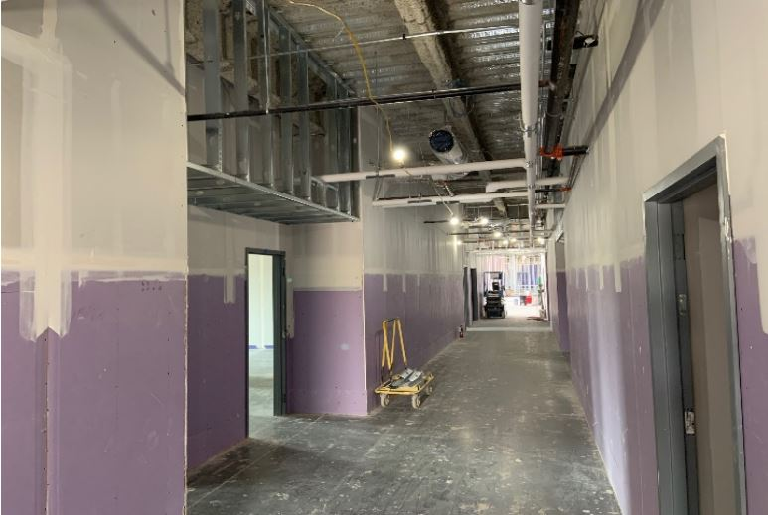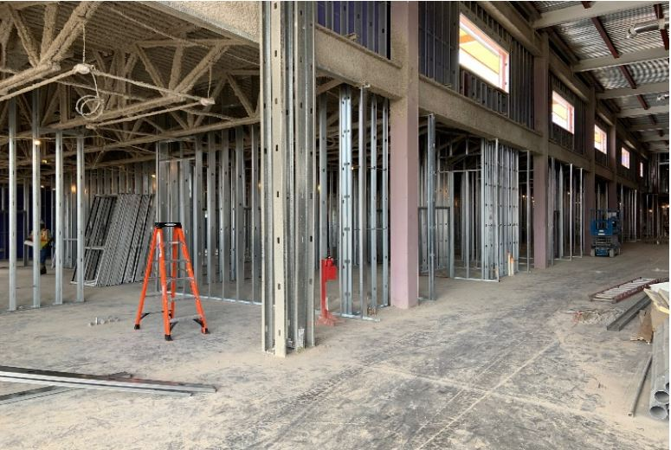



**Sect. 4 & 5 L1:** Fur downs & hard lid ceilings in progress with MEP rough-in at these locations to follow.

**Sect. 1:** CFMF & hollow metal door frames in progress with MEP in-wall rough-in to follow.

**Sect. 7 L2:** Insulation & gyp. bd. in progress with tape & float to follow.

**Sect. 4 & 5 West Elevation:** HT membrane at Metal Wall Shingles in progress with masonry veneer infill to follow.

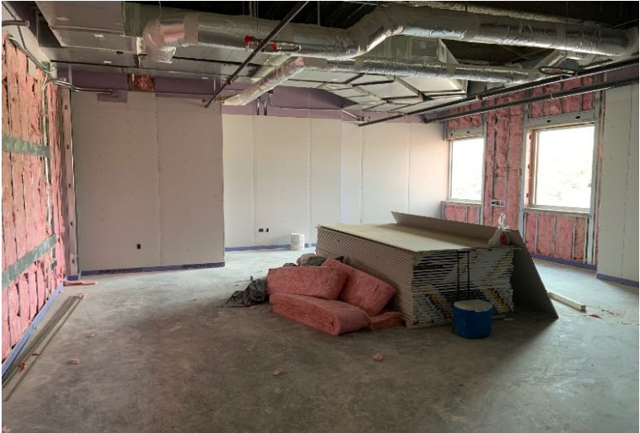

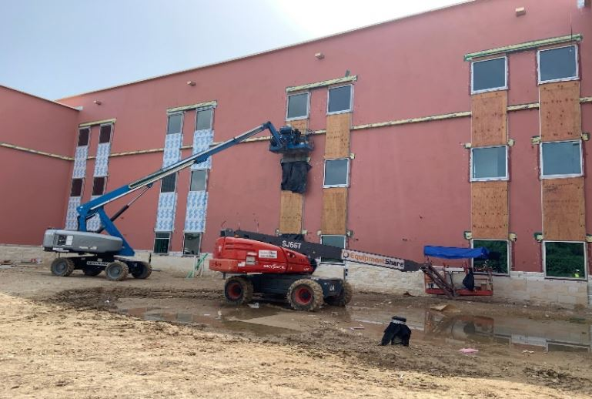

# This Month’s Major Activities:

* **Sect. 1 & 2:** CFMF & hollow metal frames
* **Sect. 2:** MSB & secondary wire build out
* **Sect. 4 & 5 L1:** Fur downs and hard lid ceilings
* **Sect. 6 & 7 L2:** Insulation & gyp. bd.
* **Sect. 8 & 9 L3:** Mech. duct & MEP wall rough-in
* **Sect. 3 Ext:** Masonry veneer at Kitchen
* **Sect. 4 & 5 Ext:** HT membrane at Wall Shingles
* **Site:** Domestic water & fire line across Rancier Ave.

# Next Month’s Major Activities:

* **Sect. 1 & 2:** MEP in-wall rough-in
* **Sect. 4 & 5 L1:** MEP rough-in at hard lid ceilings
* **Sect. 6 & 7 L2:** Tape & float at gyp. board
* **Sect. 8 & 9 L3:** Blocking, insulation & gyp. board
* **Sect. 1 Ext:** Glazing at aluminum frames
* **Sect. 2 Ext:** Masonry veneer at Electrical & Receiving
* **Sect. 4 & 5 Ext West:** Masonry veneer infill
* **Site:** Clean up and prep for grading at south parking lot

**Site:**

Design Percent Complete – 100% Construction Percent Complete – 48.30%